**PROJECT 2**

1)Write a pig script to find no of complaints which got timely response.

**LOAD:**

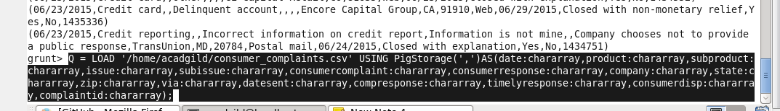

**FILTER FOR TIMELY RESPONSE:**

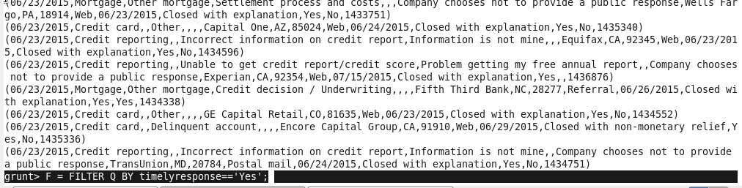

**COUNT OF COMPLAINT ID:**

C:\Users\612909\Desktop\hadoop\projpig3.PNG

**OUTPUT**

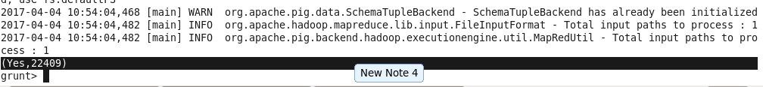

2. Write a pig script to find no of complaints where consumer forum forwarded the complaint same day they received to respective company

**CHECK FOR DATE=DATESENT**

**GROUP BY ALL**

**COUNT OF DATA**

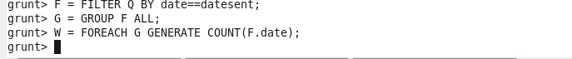

**OUTPUT**

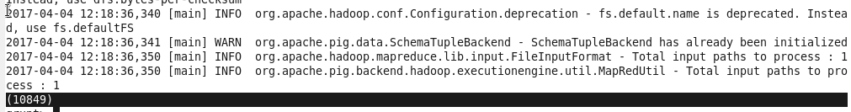

3. Write a pig script to find list of companies topping in complaint chart (companies with maximum number of complaints)

**GROUP BY COMPANY**

**COUNT OF COMPLAINT ID**

**ORDER IN DESC**

**LIMIT FOR TOP 5 ENTRIES**



**OUTPUT**



 4. Write a pig script to find no of complaints filed with product type has "Debt collection" for the year 2015

**FILTER DATA FOR DEBT COLLECTION AND YEAR=2015**

**GROUP BY PRODUCT/DATE**

**COUNT OF CORRESPONDING COMPLAINT ID**

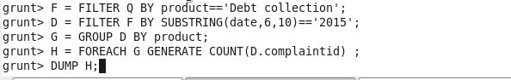

**OUTPUT**

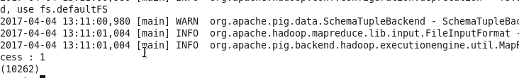

2)Write a mapreduce program to remove commas present inside the double quotes.

DRIVER: 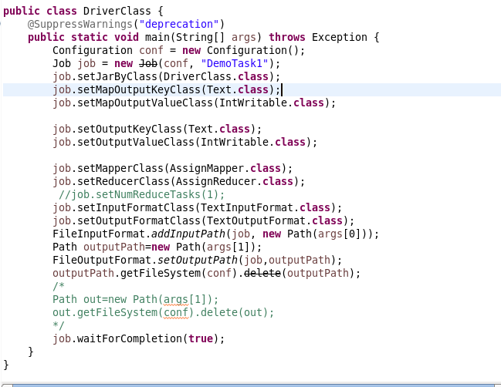

MAPPER:

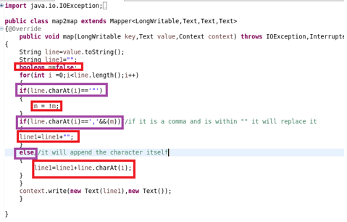

REDUCER:

